**Case study 1**

**Question 1** –

Display the number of states present in the LocationTable.

**Answer** –

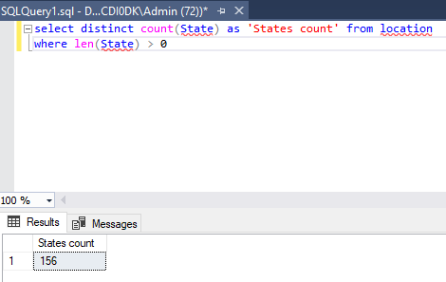

**Question 2** –

How many products are of regular type?

**Answer** –

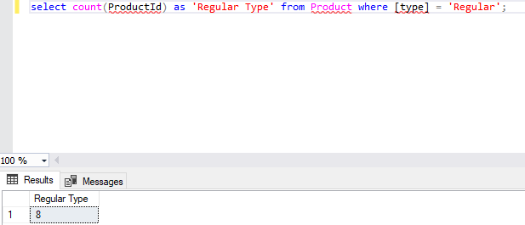

**Question 3** –

How much spending has been done on marketing of product ID 1?

**Answer** –

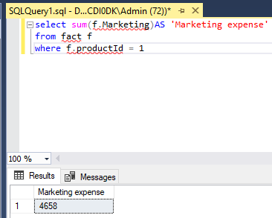

**Question 4** –

What is the minimum sales of a product

**Answer** –

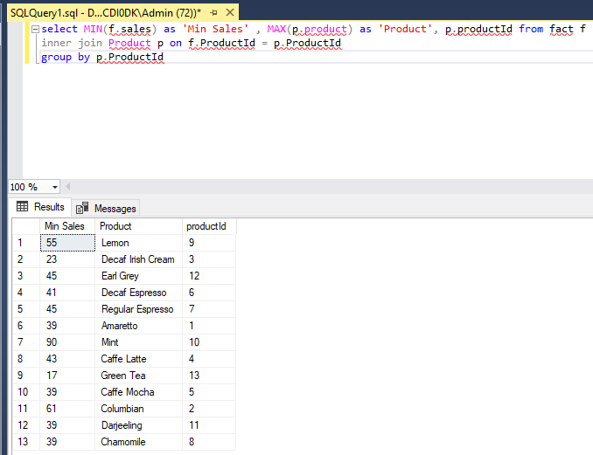

**Question 5** –

Display the max Cost of Good Sold (COGS).

**Answer** -

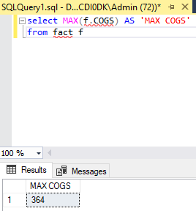

**Question 6** –

Display the details of the product where product type is coffee.

**Answer** –

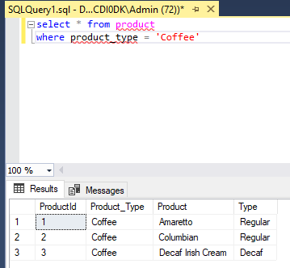

**Question 7**  -

Display the details where total expenses

**Answer** –

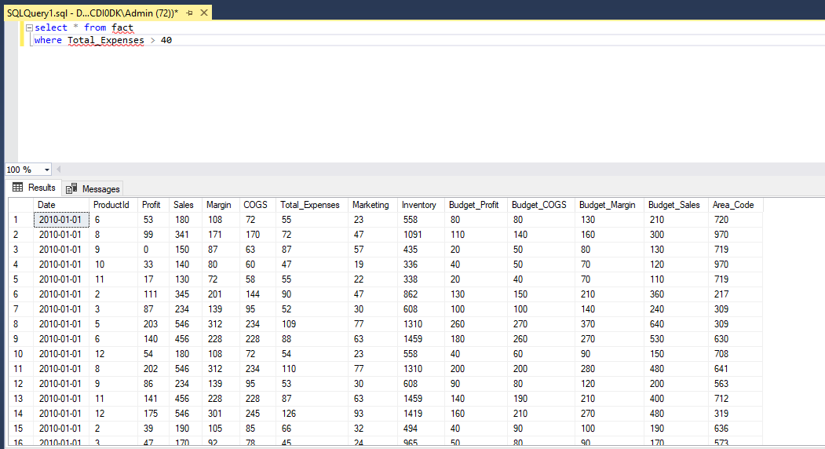

**Question 8** –

What is the average sales in area code 719?

**Answer** –

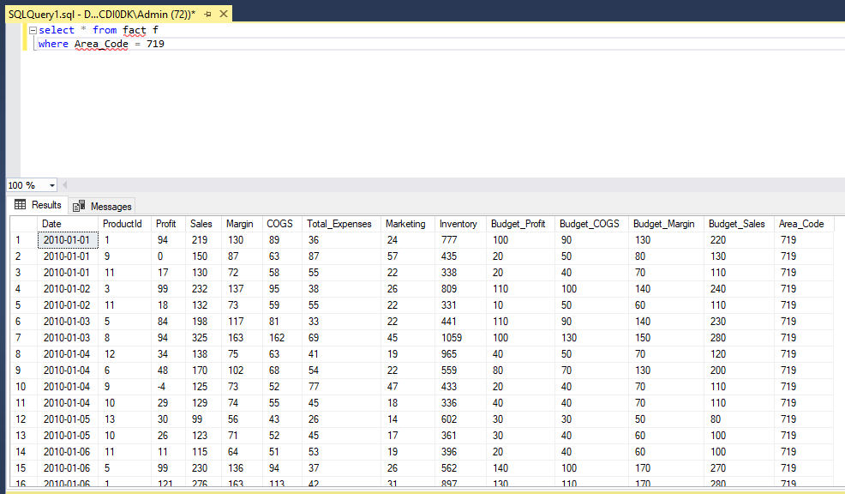

**Question 9** –

Find out the total profit generated by Colorado state.

**Answer** –

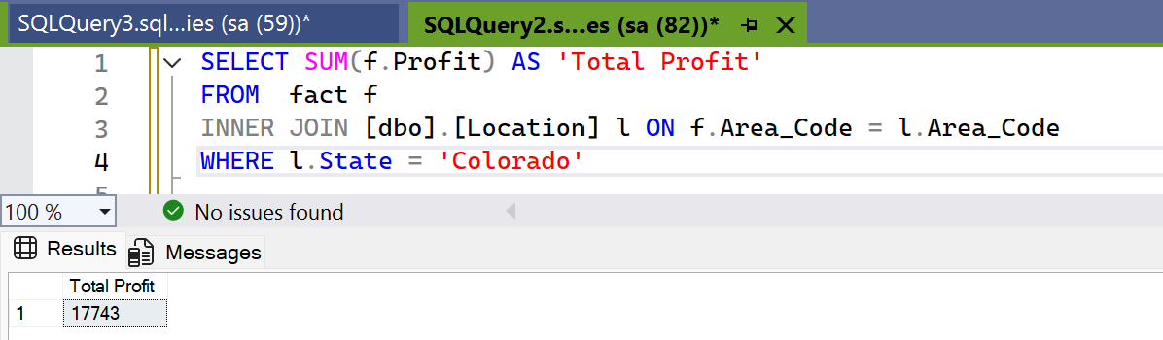

**Question 10** -

Display the average inventory for each product ID.

**Answer** –

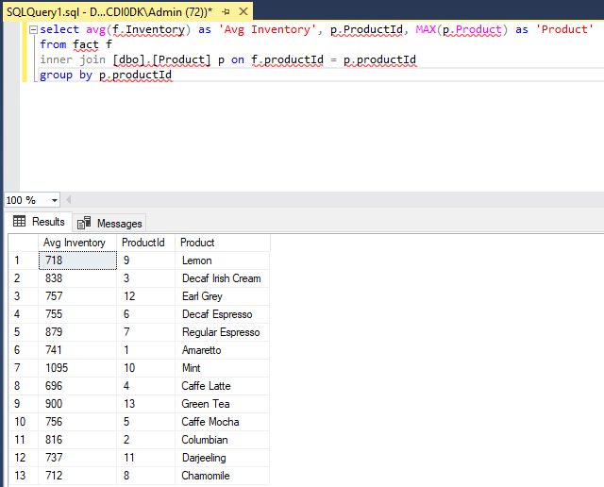

**Question 11 –**

Display state in a sequential order in a Location Table

**Answer** –

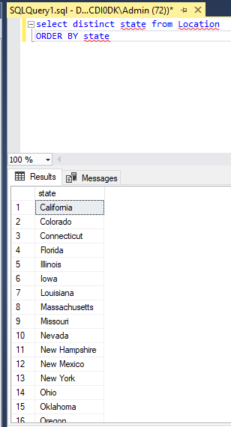

**Question 12** –

Display the average budget of the Product where the average budget margin should be greater than 100.

**Answer**  –

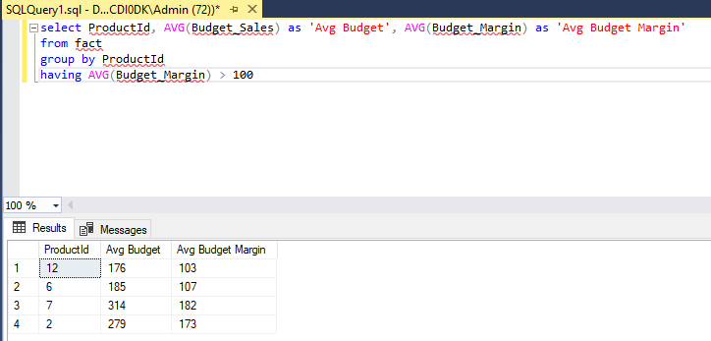

**Question 13** -

What is the total sales done on date 2010-01-01?

**Answer** –

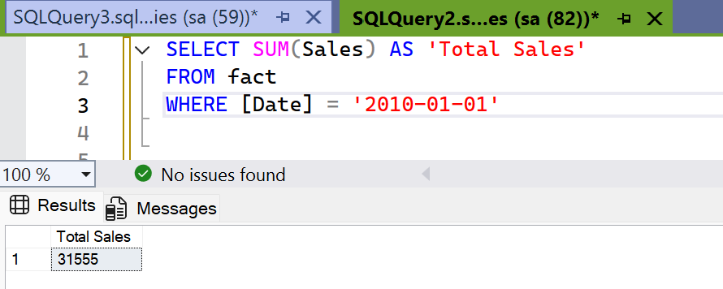

**Question 14** –

Display the average total expense of each product ID on an individual date

**Answer** –

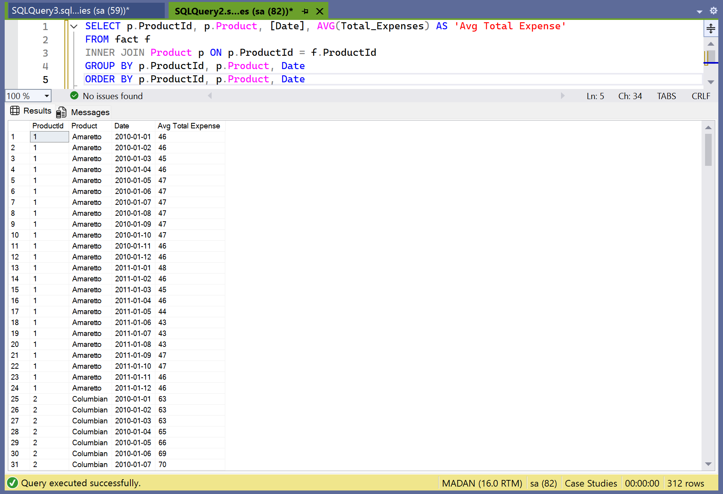

**Question 15** –

Display the table with the following attributes such as date, productID, product_type, product, sales, profit, state, area_code.

**Answer** –

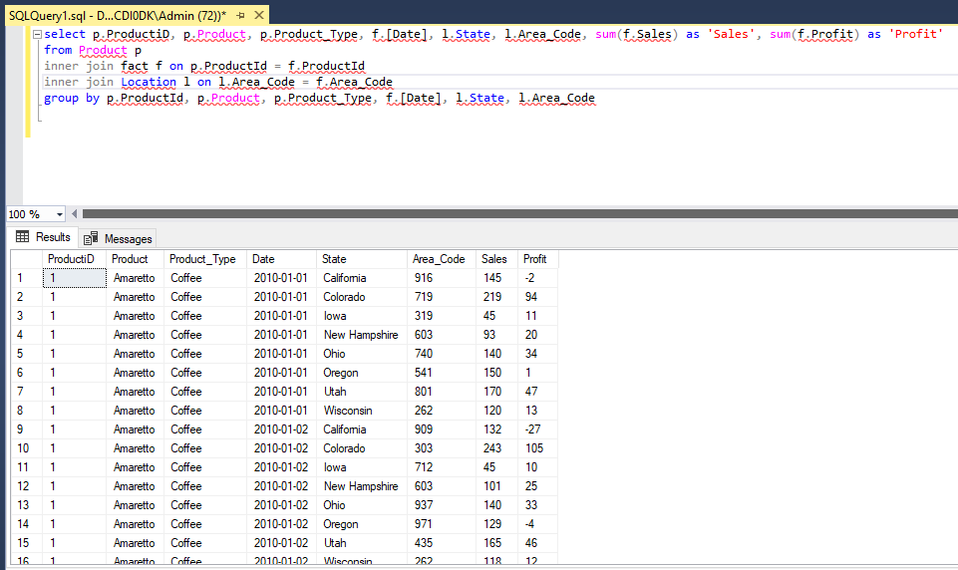

**Question 16** -

Display the rank without any gap to show the sales wise rank.

**Answer** –

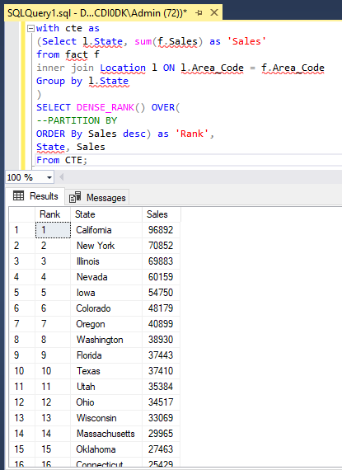

**Question 17** -

Find the state wise profit and sales.

**Answer** –

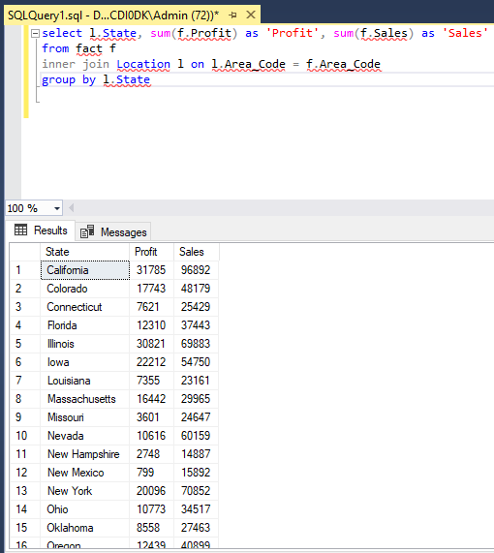

**Question 18** –

Find the state wise profit and sales along with the productname.

**Answer** –

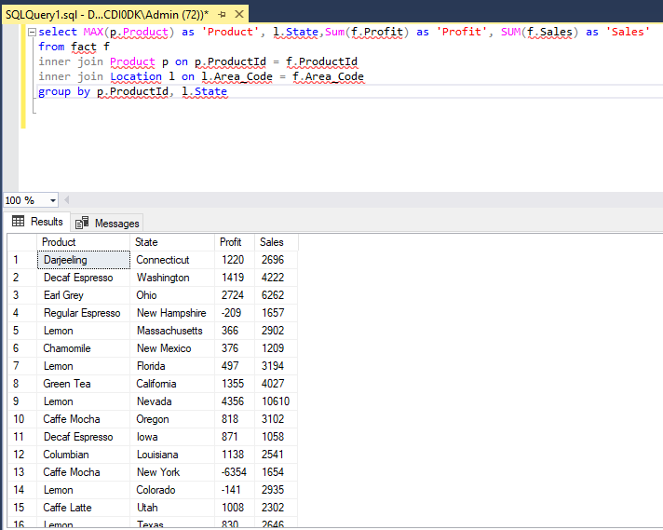

**Question 19** –

If there is an increase in sales of 5%, calculate the increasedsales

**Answer** –

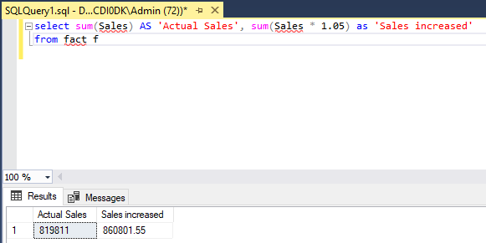

**Question 20** –

Find the maximum profit along with the product ID and producttype.

**Answer** –

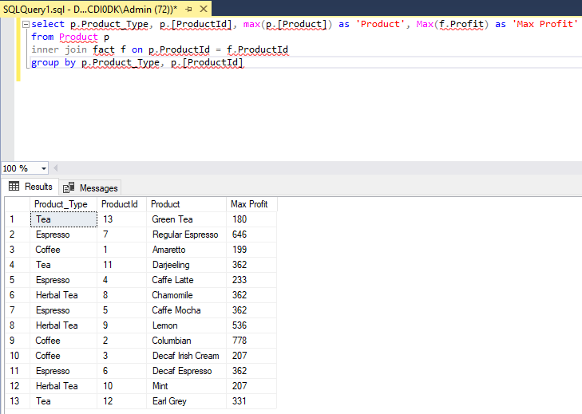

**Question 21** –

Create a stored procedure to fetch the result according to the product typefrom Product Table.

**Answer** –

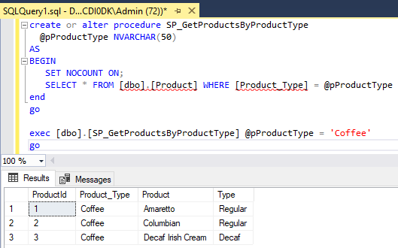

**Question 22** -

Write a query by creating a condition in which if the total expenses is lessthan60 then it is

**Answer** –

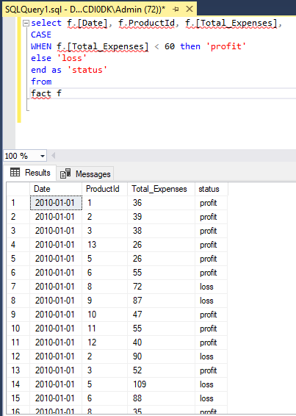

**Question 23** –

Give the total weekly sales value with the date and product IDdetails. Useroll-up to pull the data in hierarchical order.

**Answer** -

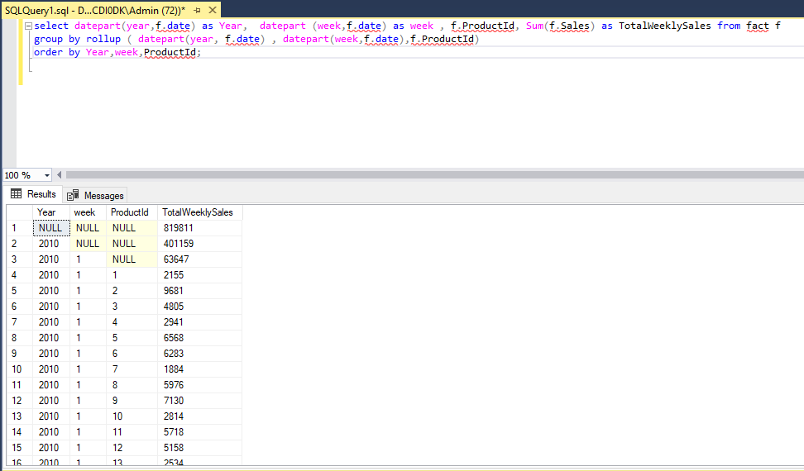

**Question 24** –

Apply union and intersection operator on the tables which consist of attribute area code.

**Answer** –

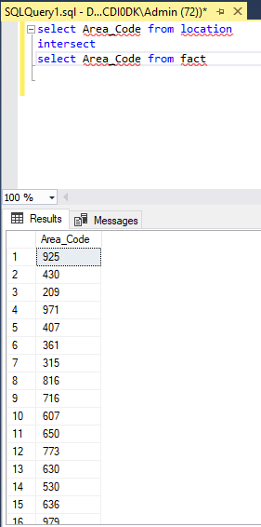

**Question 25** –

Create a user-defined function for the product table to fetch a particular product type based upon the user’s preference.

**Answer** –

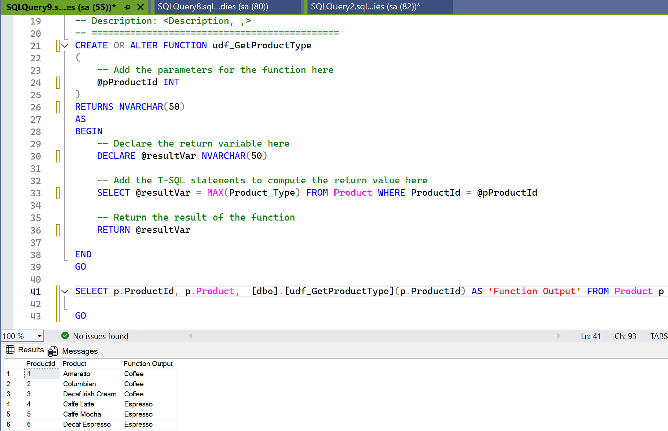

**Question 26** –

Change the product type from coffee to tea where product IDis 1 andundoit.

**Answer** –

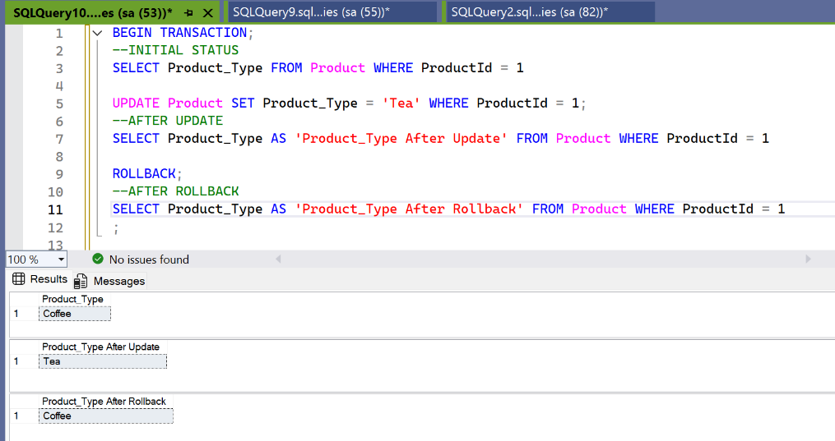

**Question 27** –

Display the date, product ID and sales where total expenses are between 100 to 200.

**Answer** –

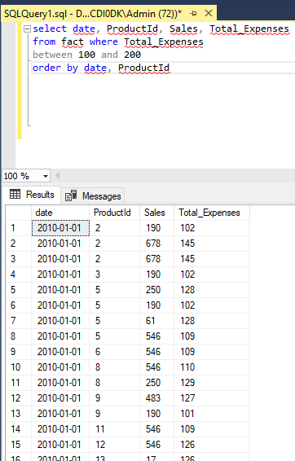

**Question 28** –

Delete the records in the Product Table for regular type.

**Answer** –

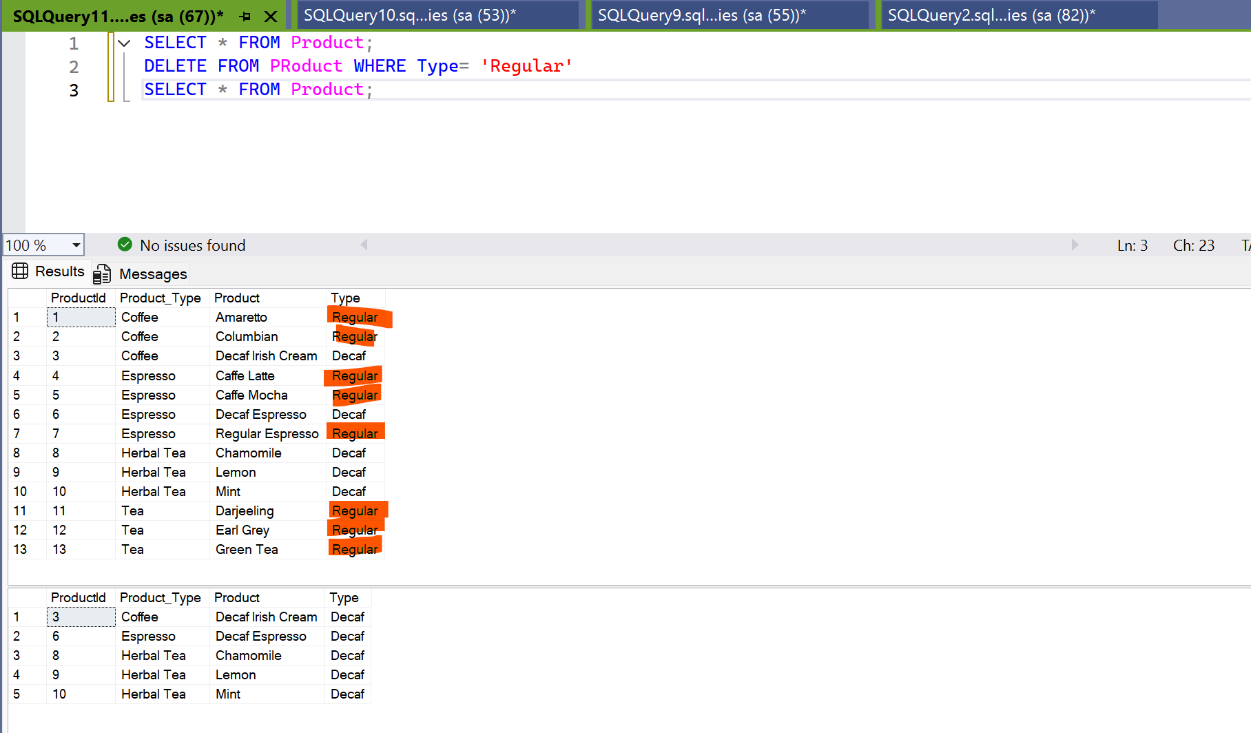

**Question 29** –

Display the ASCII value of the fifth character from the columnProduct.

**Answer** –

